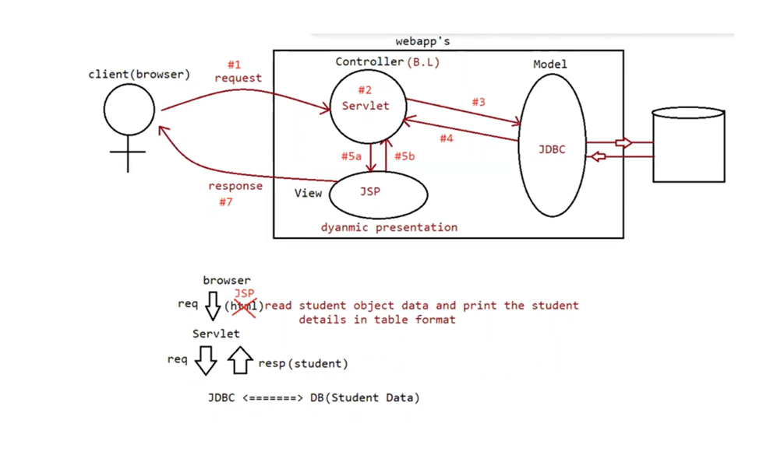

Eg: FirstAppWithJsp

set classpath with 2 jars

a. jsp-api.jar

b. jasper.jar

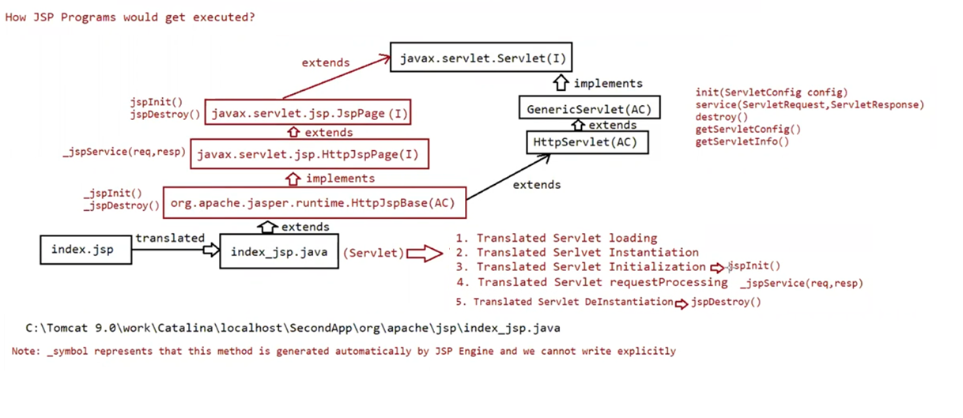

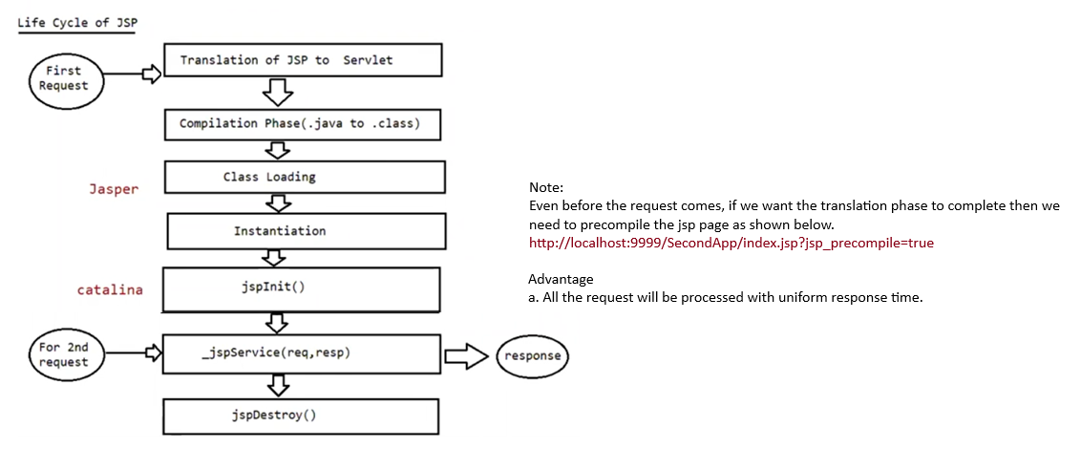

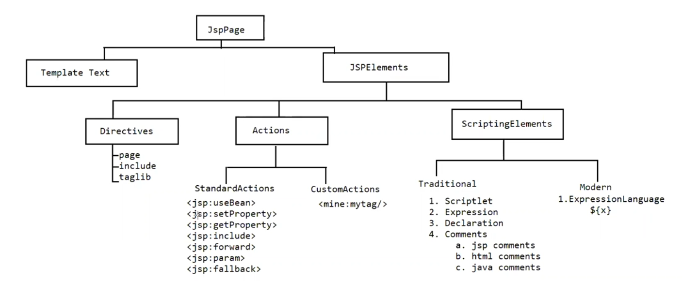

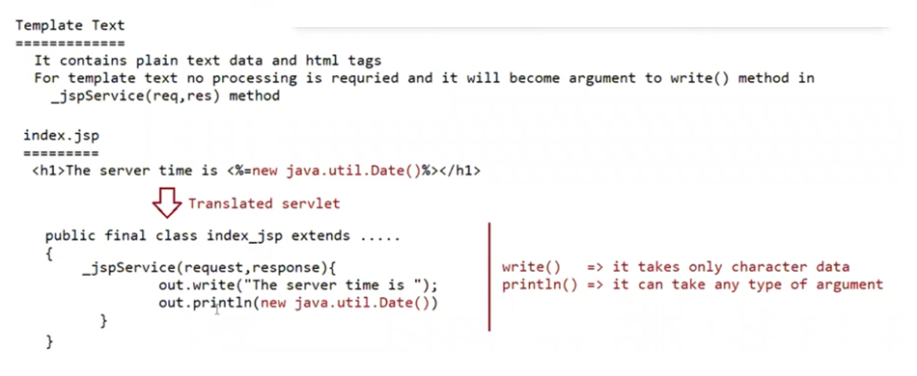

<%= %> is used for println() method

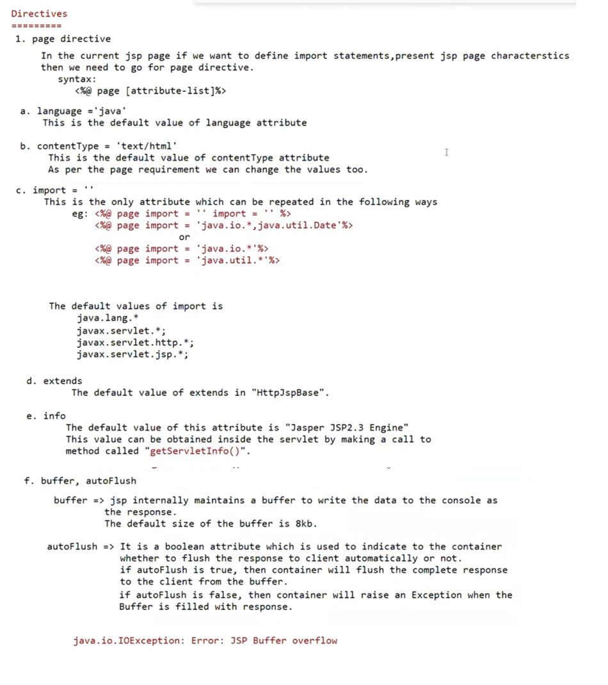

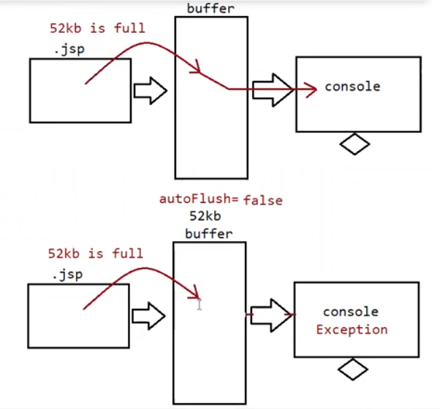

Eg: ExceptionalHandlingJsp

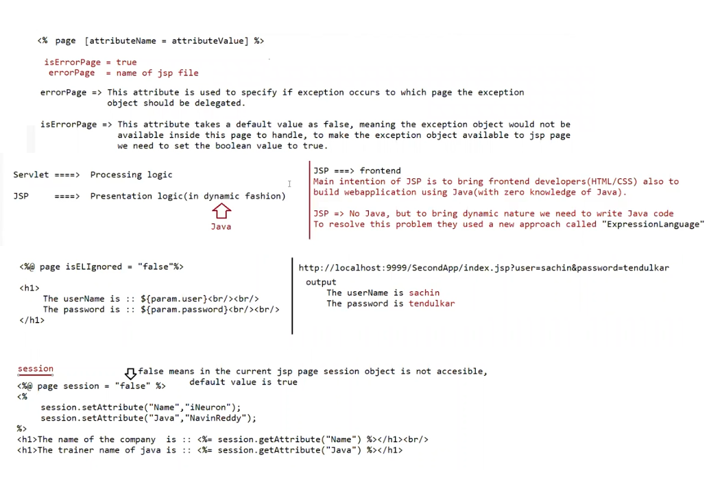

Eg: ExceptionalHandlingJsp

Eg: ExpressionLanguageJsp

Eg: SessionJsp

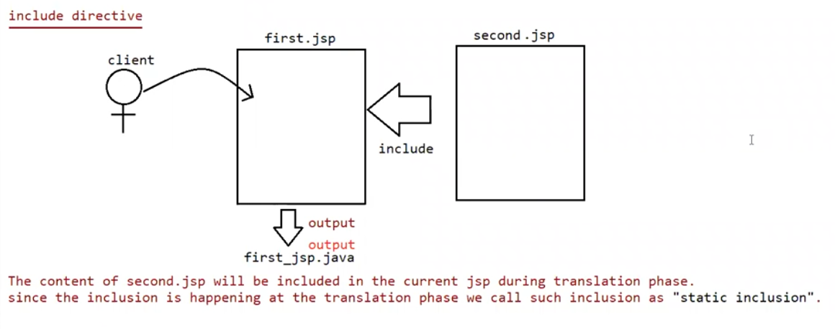

Eg: IncludeDirectiveJsp

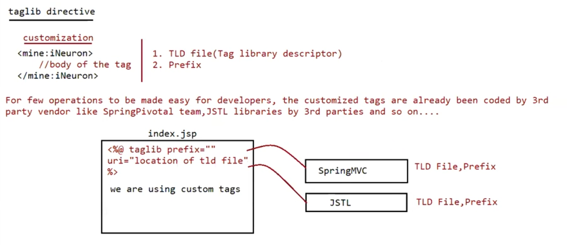

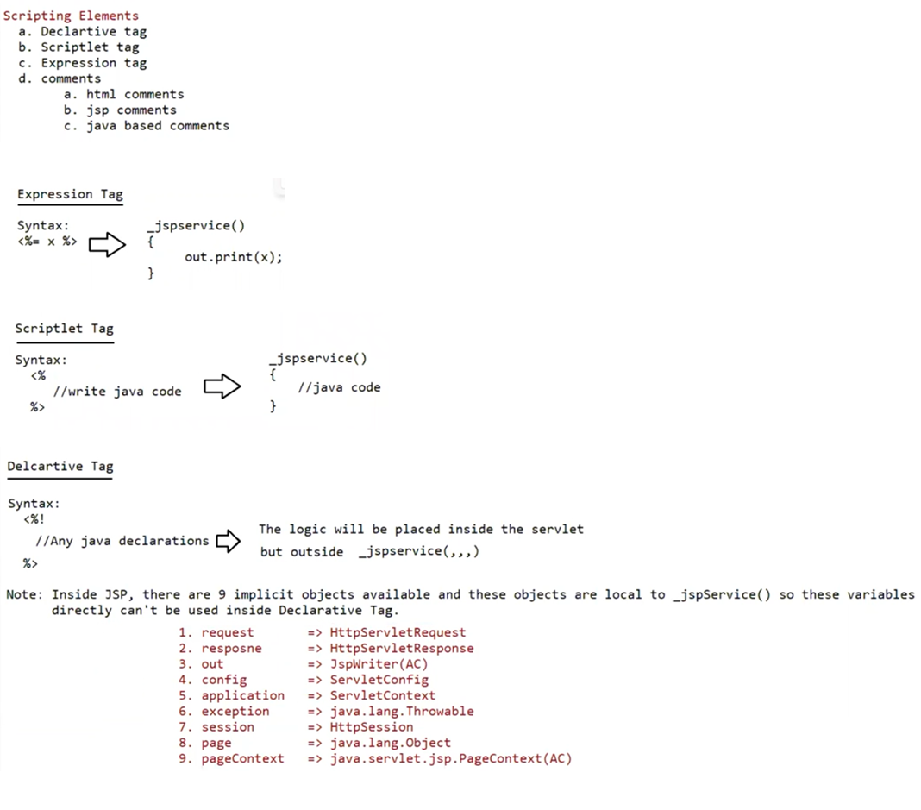

Eg: ScriptingJsp

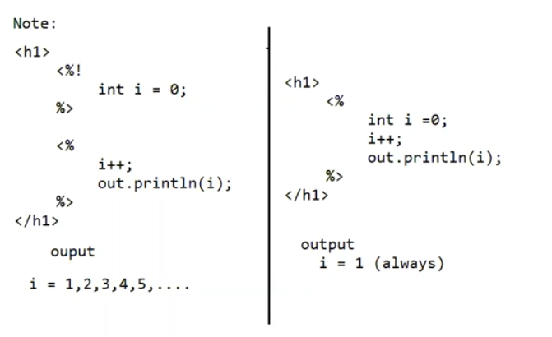

Eg: ScriptingExample2Jsp

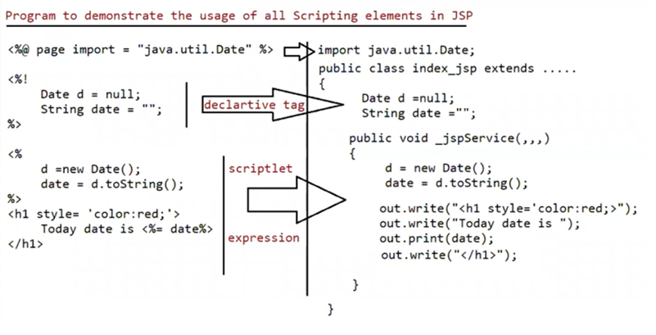

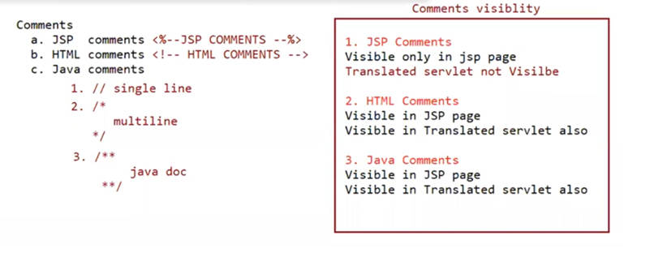

Implicit objects

Eg:RequestResponseJsp

Eg: ServletContextJsp

Eg: ServletConfigJsp

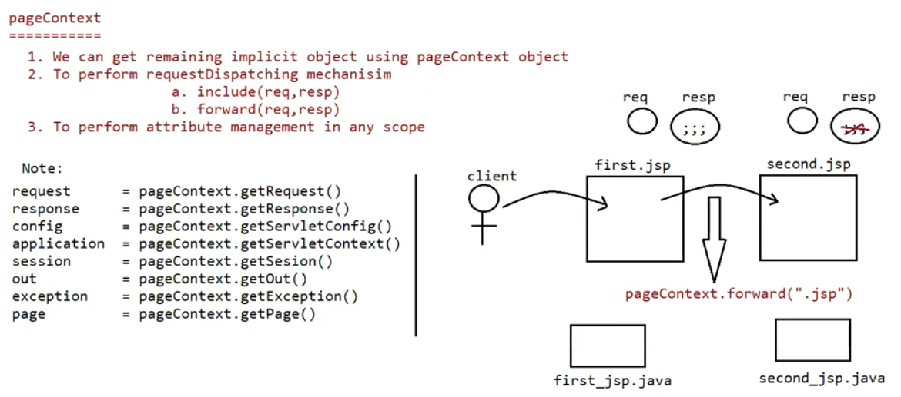

Eg: PageContextForeward

Eg:PageContextInclude